SQL Case Study
Case Study
Spotify:

Introduction:
This Spotify SQL case study focuses on analysing real-world music streaming data to gain insights into user behaviour, song popularity, and artist performance. The dataset includes tables such as Users, Songs, Singers, Albums, and Streams, which together represent how listeners interact with the platform.
By using SQL operations like JOIN, GROUP BY, ORDER BY, and aggregate functions, the study identifies the most streamed songs, top singers, and user preferences. The main goal is to apply practical SQL skills to extract meaningful insights, improve understanding of database relationships, and simulate how data analysis supports decision-making in digital music platforms like Spotify.
Understanding The dataset:
The Spotify case study contains 4 tables:
Singers

Songs
Users

Streams

Creating And Inserting Datasets Into The Tables:
Singers Table:
In this table, Singers, you’ll find details about the singers whose songs are available on Spotify. This table contains the following columns:
- singers_id: The unique ID assigned to each singer. It is an integer and serves as the primary key of the table. This field is set to auto-increment, meaning the ID value automatically increases for each new singer added.
- singer_name: The name of the singer. It is stored as a variable-length string with a maximum of 50 characters (varchar (50)).

Creating singers table,
create table singers (singers_id int auto_increment primary key, singer_name varchar(50));
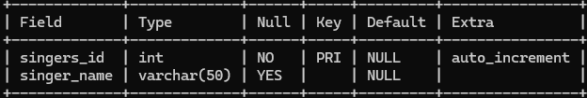
Inserting dataset into the singers table,
insert into singers (singer_name) values('Anirudh'),('Devisri Prasad'),('Arijit Singh'),('Sid Sriram'),('Karthik'),('Haricharan'),('Revanth'),('Hemachandra'),('Ranjith'),('Shreya Ghoshal')
,('Sunitha Upadrasta'),('Chinmayi Sripada'),('Geetha Madhuri'),('Ramya Behara'),('Shweta Mohan'),('Suchitra'),('Nithya Menen'),('Malavika'),('S. Thaman'),('Dhanunjay'),('Naresh Iyer'),('Madhu Priya'),('Lipsika'),('Indu'),('Smita');
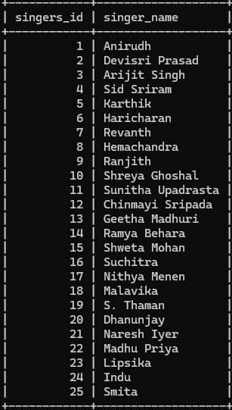

Songs Table:
This table stores details about the songs available on Spotify. It includes:
- song_id: Unique ID for each song (auto-increment, primary key).
- song_name: Name or title of the song.
- duration: Length of the song in seconds.
- singer_id: ID of the singer who performed the song (linked to the Singers table).
Creating songs table,
create table songs (song_id int auto_increment primary key,song_namevarchar(500),
duration int, singer_id int references singers_id(id));
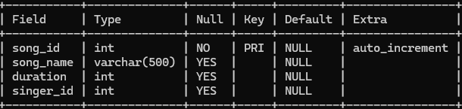
Inserting dataset into songs table,
insert into songs (song_name, duration, singer_id) values('Hukum',245,1),('Seeti Maar',240,2),('Channa Mereya',280,3),('Srivalli',230,4),('Oh My Friend',250,5),('Yemito',260,6),('Love Dhebba',245,7),('Gundellonaa',250,8),('Jai Jai Janaki',250,9),('Neetho Cheppana',260,10),('Manasa Manasa',275,11), ('O Priya Priya',245,12),('Darlingey',260,13),(‘Chinnukulanni’,250,14),('Melikalu',245,15),('Chinni Chinni Aasalu',245,16),('Okkasari',250,17),('Panchadara Bomma',230,18),('Blockbuster',240,19),('Ye Mera Jahan',250,20),('Priya Priya',250,21),('Vachinde',270,22),('Rangamma Mangamma',240,23),('Choosi Choodangaane',245,24),('Ee Velalo Neevu',250,25);
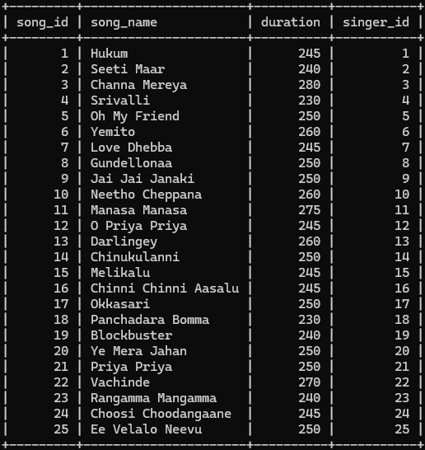
Users Table:
This table stores information about Spotify users. It includes:
- user_id: Unique ID for each user (auto-increment, primary key).
- user_name: Name of the user, stored as text up to 100 characters.
Creating users table,
create table users(user_id int auto_increment primary key, user_name varchar(100));
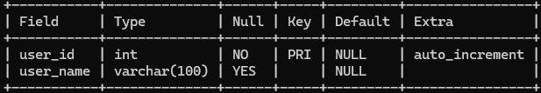
Inserting dataset into the users table,
insert into users (user_name) values('Pavani'),('Krishna'),('Anusha'),('Prasanna'),('Kamali'),('Raju'),('Jagadeesh'),('Srinu'),('Sumaja'),('Mounika'),('Harika'),('Priya'),('Ramya'),('Kishore'),('Praneeth'),('Parwez'),('Yashwanth'),('Srinadh'),('Supriya'),('Mahesh'),('Ravi Teja'),('Suresh'),('Ramesh'),('Satish');
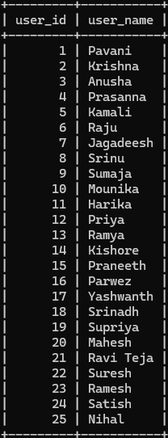
Streams Table:
This table stores details about user listening activity on Spotify. It includes:
- stream_id: Unique ID for each stream record (auto-increment, primary key).
- user_id: ID of the user who listened to the song.
- song_id: ID of the song that was played.
- singer_id: ID of the singer of the song.
- listen_date: The date on which the song was streamed.
Creating streams table,
create table streams
(stream_id int auto_increment primary key, user_id int references user_id(id),song_id int references song_id(id),singer_id int references singer_id(id),listen_date date);
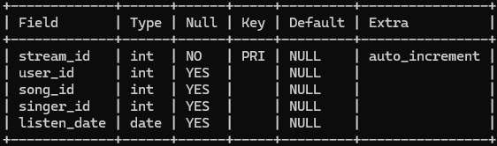
Inserting dataset into streams table,
insert into streams (user_id, song_id, singer_id, listen_date) values
(2,3,5,'2025-07-01'),(3,6,12,'2025-07-12'),(4,22,21,'2025-07-10'),(8,20,1,'2025-07-23'),(3,7,10,'2025-08-11'),(2,1,1,'2025-08-12'),(2,3,4,'2025-08-19'),(6,6,6,'2025-08-22'),(1,4,8,'2025-09-02'),(7,6,22,'2025-09-13'),(6,3,10,'2025-09-28'),(2,3,5,'2025-09-22'),(8,10,4,'2025-09-04'),(7,4,22,'2025-09-07'),(9,3,1,'2025-10-03'),(4,23,4,'2025-10-07'),(4,1,7,'2025-10-21'),(6,1,1,'2025-10-22'),(1,1,1,'2025-10-10');
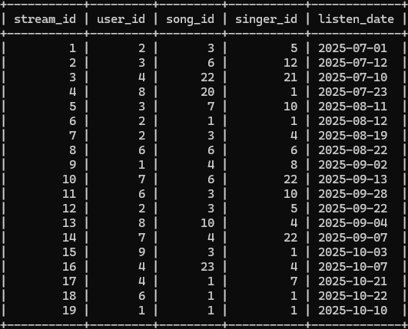
Problem Statement And Solutions:
Following are the business questions that Spotify wants answers to. Use SQL to answer them. All the best! 🎵
- Write an SQL query to display the song ID, song name, singer ID, and singer name by joining the songs and singers tables based on their matching singer IDs.
Solution:
select song_id , song_name ,singer_id, singer_name from songs, singers where songs. singer_id=singers. singers_id;
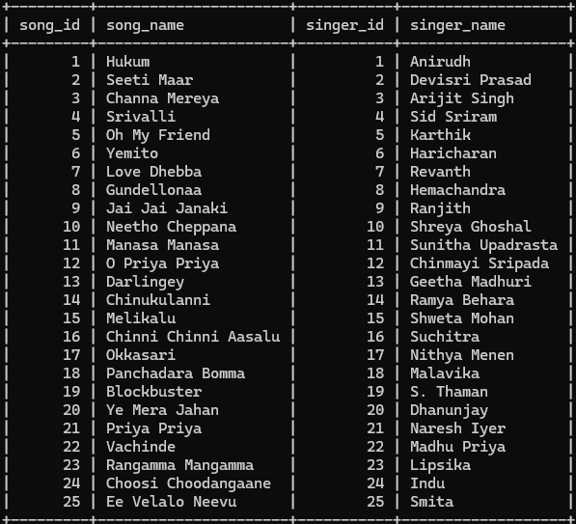

- Write an SQL query to display the names of songs and their duration from the songs table where the duration is greater than 240 seconds.
Solution:
select song_name, duration from songs where duration>240;

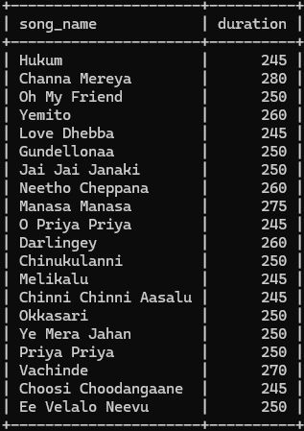

- Write SQL queries to find the longest song duration from the songs table using two different methods:

- Using the MAX () aggregate function.
- Using the ORDER BY and LIMIT clauses to retrieve the song with the highest duration.
Solution:
- select max(duration) from songs;

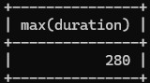

- select distinct(duration) from songs order by duration desc limit 0,1;
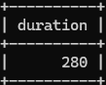

- Write an SQL query to display each singer’s name along with the average duration of their songs. Use a JOIN between the songs and singers tables, and group the results by the singer’s name.
Solution:
select si. singer_name, avg (s. duration) as avg_ duration from songs s join singers si on s. singer_id=si. singers_id group by si.singer_name;
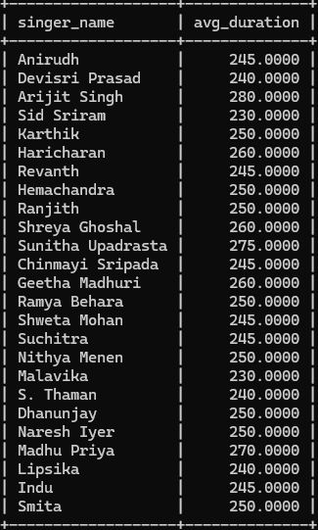
- Write an SQL query to display all the songs sung by the singer ‘Revanth’ along with the number of times each song was streamed. Use the Streams, Songs, and Singers tables with appropriate JOIN operations, and group the results by the song name.
- The filtering condition (WHERE si.singer_name = 'Revanth')
- The use of JOINs across three tables
- The aggregation using COUNT() and GROUP BY
Solution:
SELECT si.singer_name, s.song_name, COUNT(st.stream_id) AS plays
FROM Streams st
JOIN Songs s ON st.song_id = s.song_id
JOIN Singers si ON s.singer_id = si.singers_id
WHERE si.singer_name = 'Revanth'
GROUP BY si.singer_name, s.song_name;
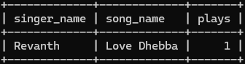

- Write an SQL query to display the top 5 most played songs by a specific user (User ID = 2). The output should include the song name, singer name, and the number of times each song was streamed. Use appropriate JOINs between the Streams, Songs, and Singers tables, and sort the results in descending order of play count.
- The purpose (top 5 songs by a specific user)
- The required output columns
- The SQL concepts used — JOIN, COUNT(), GROUP BY, ORDER BY, and LIMIT.
Solution:
SELECT s.song_name, si.singer_name, COUNT(st.stream_id) AS play_count
FROM Streams st
JOIN Songs s ON st.song_id = s.song_id
JOIN Singers si ON s.singer_id = si.singers_id
WHERE st.user_id = 2
GROUP BY s.song_id, s.song_name, si.singer_name
ORDER BY play_count DESC
LIMIT 5;

